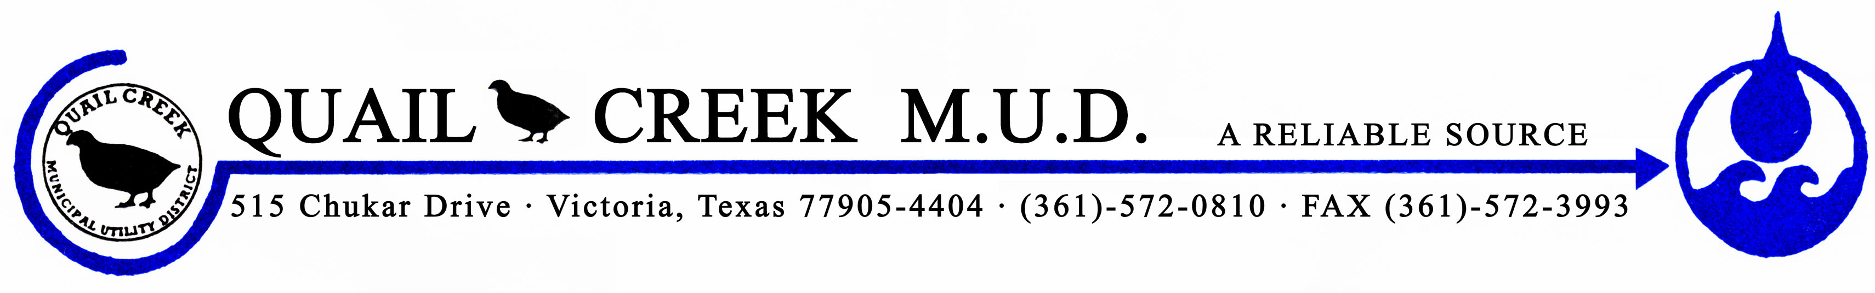 June 1, 2021

Dear Resident,

The Quail Creek MUD, PWS 2350004, failed to collect the required number of triggered source bacteriological samples for fecal indicator monitoring of the groundwater system during January 2021. This monitoring is required by the Texas Commission on Environmental Quality’s “Drinking Water Standards” and the federal “Safe Drinking Water Act,” Public Law 95-523.

Triggered source samples are used to monitor water quality and indicate if the water is free of fecal indicator bacteria. Following a positive routine total coliform result in our distribution system, our water system is required to submit one triggered source sample for every active groundwater well source. Failure to collect all required triggered source samples is a violation of the monitoring requirements and we are required to notify you of this violation.

What should I do?
There is nothing you need to do at this time.

What is being done?
Samples were collected, submitted and the results came back absent. Precautions have been taken and samples will collected and sent in in a timely manner.

*Please share this information with all the other people who drink this water, especially those who may not have received this notice directly (for example, people in apartments, nursing homes, schools and businesses). You can do this by posting this notice in a public place or distributing copies by hand or mail.*

For more information, please contact Daniel O. Jimenez at 361-572-0810 or 515 Chukar Drive, Victoria, TX 77905.

Sincerely,
Daniel O. Jimenez
District Manager
Quail Creek MUD

